**Batch: A2 Roll No.: 16010121045**

**Experiment / assignment / tutorial No._______**

**Grade: AA / AB / BB / BC / CC / CD /DD**

**Signature of the Staff In-charge with date**

**PCB Workshop (2021-2022)**

**Design and Manufacturing of Printed circuit Board (PCB).**

**Post Lab Subjective/Objective type Questions.**

1. **Describe the function of double-sided UV Exposure unit.**

A double-sided UV Vacuum exposure unit is a tool for the production of parts such as double-sided PCBs. The vacuum makes these UV exposure units suitable for processing UV sensitive flexible substrate materials.

1. **List the software’s used for PCB layout design and explain how to design layout using DIPTRACE or EAGLE software.** (DONE)

The software used for PCB layout design are:

* PROTEL (Altium Designer)
* PADS (Power PCB)
* ORCAD
* Allegro
* Eagle（Easily Applicable Graphical Layout Editor)

**Write and explain in short, the steps for fabrication of PCB.**

PCB fabrication is the process or procedure that transforms a circuit board design into a physical structure based upon the specifications provided in the design package. The PCB is fabricated in the following steps:

* Imaging desired layout on copper clad laminates.
* Etching or removing excess copper from inner layers to reveal traces and pads.
* Creating the PCB layer stack up by laminating board materials at high temperatures.
* Drilling holes for mounting holes, through hole pins and vias.
* Etching or removing excess copper from the surface layer to reveal traces and pads.
* Plating pin holes and via holes.
* Adding protective coating to surface or solder masking.
* Silkscreen printing reference and polarity indicators, logos or other markings on the surface.
* Optionally, a finish may be added to copper areas of surface.

1. **Explain PCB in details.**

A printed circuit board **(PCB)** is a laminated sandwich structure of conductive and insulating layers. PCBs have two complementary functions. The first is to affix electronic components in designated locations on the outer layers by means of soldering. The second is to provide reliable electrical connections between the component's terminals in a controlled manner often referred to as PCB design.

1. 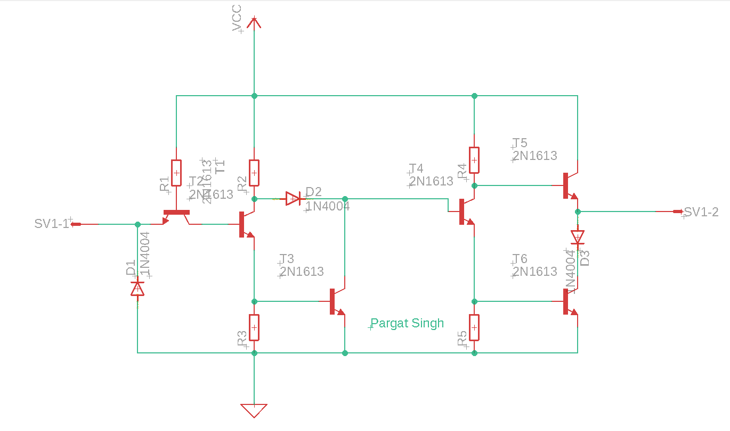**Draw any one electronic schematic diagram with its PCB Layout.**

